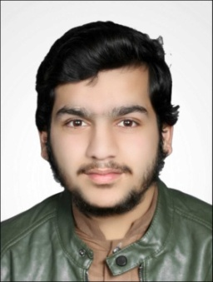**Muhammad Haroon Ashraf**

**Father Name:** Muhammad Ashraf

**D.O.B:** Apr 04, 1998

**Contact:**  +973 3306 1262

**Marital Status:** Single

**CNIC:** 13302-8870415-3

**Passport No.** PD1844151

**CPR No.** 980424178

**E-mail:**  ha939774@gmail.com

**Nationality & Domicile:** Pakistani |Haripur-KPK

**Address:** Moh Eid Gah, Near Railway Station |Haripur-KPK

**Religion:** Islam

**Professional Objective:**

To obtain an engineering position in an reputed organization where I will have the opportunity to utilize my technical training and knowledge and grow up with Organization.

**Personal Strengths & Profile:**

Personal Skills: Commended for reliability and trustworthiness.

Have a high sense of responsibility and believe in “It pays to work hard”.

Other skills include Interpersonal skills, Analytical skills, report-writing skills etc.

**Education:**

2015 SSC (Science)

Govt. Centennial Model Higher Secondary School, Haripur

73%

2017 HSSC (Science)

Bright Vision Model School & College, Haripur

81%

**Professional Experience:**

June 2017

to Dec 2019 Work in Fabrics Shop (Salesman)

Dec 2019-Onwards **Training**

Haji Hassan Group BSC(c), Bahrain

Dec 2019-Omwards **Job** (Helper/Office Boy/Storekeeper)

Haji Hassan Group BSC(c), Bahrain

**Technical Skills:**

Sports Cricket, Football, Badminton

Languages Urdu, English, Hindi, Punjabi